**Advanced Java**

**Lab Assignment 2**

**Date: 3/7/2018**

1. **Create a servlet which calculates the income tax given the income of the person. The rules for calculating the tax are as follows:**

**If income is <20,000 then 2% tax should be paid,**

**If income is >=20,000 and <50,000 then 7% tax should be paid,**

**If income is >=50,000 and <2, 00,000 then 10% tax should be paid,**

**If income is >=2, 00,000 then 15% tax should be paid.**

**Additionally if the age of the person is above 55 years 1% relaxation is provided.**

**Input from the user has to be accepted from an html page.**

**Index.html**

<html>

<head>

<title>Property Commission Calculation</title>

<meta charset="UTF-8">

<meta name="viewport" content="width=device-width, initial-scale=1.0">

</head>

<body>

<center>

<form method="POST" action="ProperyCommCalc">

<h1>Calculate Your Commission</h1>

<br>

<br>

Enter Name:&emsp;&emsp;&emsp;&emsp;&emsp;<input type="text" name="name">

<br>

<br>

Enter Property Value:&emsp;<input type="text" name="pValue">

<br>

<br>

Enter Days:&emsp;&emsp;&emsp;&emsp;&emsp;<input type="text" name="NoDays">

<br>

<br>

<input type="submit" value="Calculate">

</form>

</center>

</body>

</html>

**ProperyCommCalc.java**

protected void processRequest(HttpServletRequest request, HttpServletResponse response)

throws ServletException, IOException {

String name = request.getParameter("name");

double value = Integer.parseInt(request.getParameter("pValue"));

int days = Integer.parseInt(request.getParameter("NoDays"));

DecimalFormat df = new DecimalFormat(".##");

double comm;

if(value >= 300000){

comm = value*0.20;

df.format(comm);

}

else if(value >= 100000){

comm = value*0.15;

df.format(comm);

}

else if(value >= 50000){

comm = value*0.12;

df.format(comm);

}

else{

comm = value*0.05;

df.format(comm);

}

if(days < 15){

double commbon = comm*.02;

comm = comm+commbon;

df.format(comm);

}

response.setContentType("text/html;charset=UTF-8");

try (PrintWriter out = response.getWriter()) {

/* TODO output your page here. You may use following sample code. */

out.println("<!DOCTYPE html>");

out.println("<html>");

out.println("<head>");

out.println("<title>Servlet ProperyCommCalc</title>");

out.println("</head>");

out.println("<body>");

out.println("<center>");

out.println("<h1>Welcome "+ name +"</h1>");

out.println("<h3>You Are Entitled to Get Commssion of Rs. </h3> </h2>" + df.format(comm) + "</h3>");

out.println("</center>");

out.println("</body>");

out.println("</html>");

} }

**Output:**

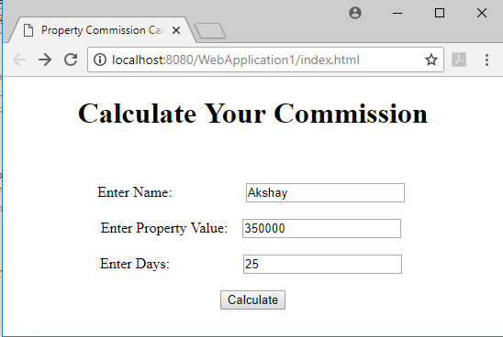

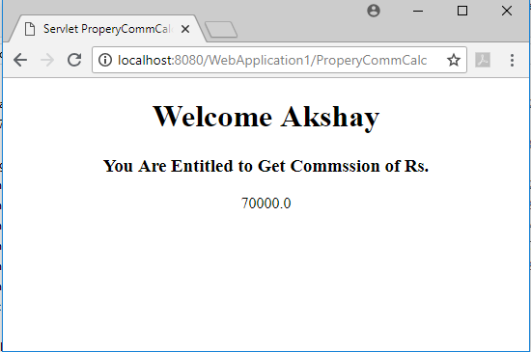

1. **Create a servlet which calculates the commission of a property agent. The rules for calculating the commission are as follows:**

**If property value is <50,000 then commission is 5% of the property’s value,**

**If property value is >=50,000 and <1 lakh then the commission is12%,**

**If the property value is >=1 lakh and <3 lakhs then the commission is 15%,**

**If the property value is more than 3 lakhs then commission is 20%. Additionally if the no. of days in which the property is found out is less than 15 days then additional 2% commission has to be paid.**

**Input from the user has to be accepted from an html page.**

**Index.html**

<html>

<head>

<title>Calculate Tax</title>

<meta charset="UTF-8">

<meta name="viewport" content="width=device-width">

</head>

<body>

<div></div>

<center>

<form method="POST" action="TaxCalculator">

<h1>CALCULATE YOUR TAX</h1>

<br>

<br>

Enter Name: <input type="text" name="name">

<br>

<br>

Enter Age: <input type="text" name="age">

<br>

<br>

Enter Income: <input type="text" name="income">

<br>

<br>

<input type="submit" value="Calculate">

</form>

</center>

</body>

</html>

**TaxCalculator.java**

protected void processRequest(HttpServletRequest request, HttpServletResponse response)

throws ServletException, IOException {

String name = request.getParameter("name");

int age = Integer.parseInt(request.getParameter("age"));

double income = Integer.parseInt(request.getParameter("income"));

double tax;

if(income >= 200000){

tax = income*0.15;

}

else if(income >= 50000){

tax = income*0.1;

}

else if(income >= 20000){

tax = income*0.07;

}

else{

tax = income*0.02;

}

if(age > 55){

double taxreb = tax*.01;

tax = tax-taxreb;

}

response.setContentType("text/html;charset=UTF-8");

try (PrintWriter out = response.getWriter()) {

/* TODO output your page here. You may use following sample code. */

out.println("<!DOCTYPE html>");

out.println("<html>");

out.println("<head>");

out.println("<title>Servlet TaxCalculator</title>");

out.println("</head>");

out.println("<body>");

out.println("<center>");

out.println("<h1>Welcome "+ name +"</h1>");

out.println("<h3>Your Tax Amount to Be Paid is </h3> <h2>" + tax + "</h2>");

out.println("</center>");

out.println("</body>");

out.println("</html>");

}

}

**Output:**

